Please join the Phyllis Wheatley YWCA
Community Conversation
Exploring the Life and Works
of Writer and Novelist
Ta-Nehisi Coates

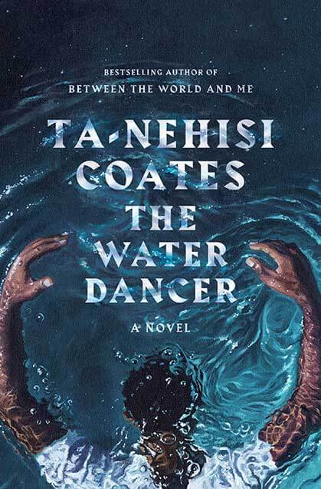

Saturday, February 29, 2020
12:00 PM
901 Rhode Island Ave., NW
Washington, DC 20001

